**Project Management Plan for Project Nexus**

MAN 4583

Dr. Cristian Alecse

June 19, 2024

**Team:** 1

**Team Members:**

# Kailee Block

Patrick Brown

Daniella Calderon

Maayan Malul

Tyler Mann

Karishma Tirlokie

Rudolph Zwaans

1. **Scope Management Plan**
2. **Project Scope Statement**

* Project Nexus is the creation of a resource application made for restaurants.
* Training and helpful guidelines are inaccessible to many restaurants and have proven to increase employee turnover.
* Project Nexus has two clear goals, an average user rating of 4.5 out of 5 stars, along with a total of 1,022 subscribers within the first month of launch.
* We chose a target of 1,022 subscribers to achieve a break-even point and secure a $50,000 profit within seven months of launch. Detailed financial projections supporting this goal are provided in the appendices (Figure 14).
* Project Nexus has two main deliverables, being the creation of our application and the marketing campaign. Our project excludes marketing directly for restaurants, assisting in restaurant structure, menu development, and lastly, development of host servers for the application.
* Success criteria will be defined as follows; reaching 1,022 subscribers within the first month of our launch, along with an average application rating of 4.5 out of 5 stars.
* Utilizing a project priority matrix, we will prioritize time first, secondly prioritize cost, and lastly, we will prioritize our scope.

1. **Scope Breakdown**

* A work breakdown structure is crucial to our project because it will offer clear organization, improved planning, and enhanced cost and budgeting management.
* Our work breakdown structure has a total of sixteen work packages with seven major summary tasks. We will begin with research and planning, consisting of market research and defining users. We will follow through with seeking government support, app development, testing, deployment, and lastly, post-launch activities.
* **Work Breakdown Structure**

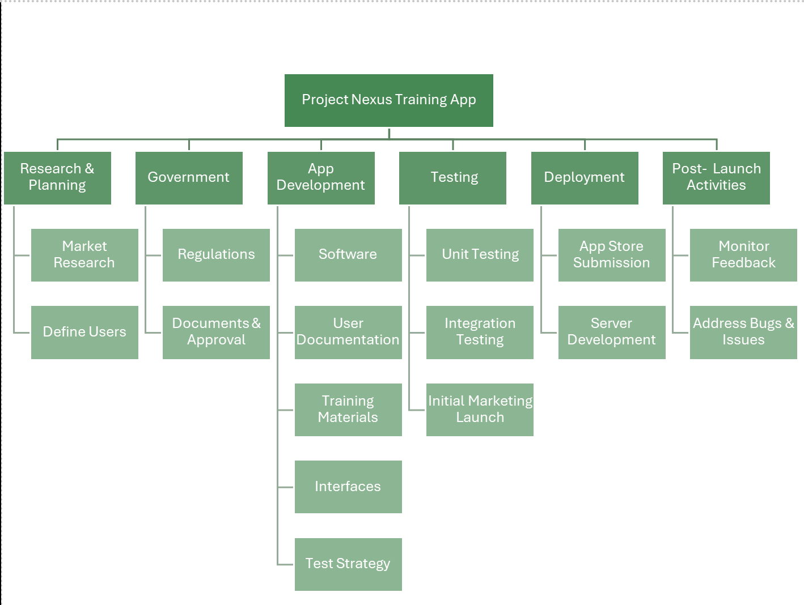

**Figure 1**

**B. Schedule Management Plan**

The purpose of creating and managing a project schedule for our training application is to have an organized structure for our project tasks. These tasks will be completed in a timely manner to avoid any delays in the application development time frame.

1. **Activity Duration Estimates and Predecessors**

* We utilized the top-down method to obtain activity duration estimates. Our technical director Rudolph Zwaans gave us a high-level estimate based on the overall scope and deliverables which were broken down by using parametric estimates. We identified key variables and impacts by using historical data to estimate the current project parameters.
* **Time Duration Estimates Graph:**

| **Work Packages** | **Predecessors** | **Time Duration** |
| --- | --- | --- |
| 1. **Market Research** | None | 2 weeks |
| 1. **Define Users** | Market Research | 1 week |
| 1. **Identify Regulations** | None | 1 week |
| 1. **Documents/Approval** | Regulations | 2 weeks |
| 1. **Software** | Approval | 2 months |
| 1. **User Documentation** | Define Users | 1 week |
| 1. **Training Materials** | Approval | 2 weeks |
| 1. **Interfaces** | Software | 3 weeks |
| 1. **Test Strategy** | Software | 1 week |
| 1. **Unit Testing** | Test Strategy | 1 week |
| 1. **Integration Testing** | Test Strategy | 1 month |
| 1. **Initial Marketing Launch** | None | 1 month |
| 1. **App Store Submission** | Integration Testing | 1 week |
| 1. **Server Development** | Integration Testing | 2 weeks |
| 1. **Monitor Feedback** | Server Development | 3 weeks |
| 1. **Address Bugs and Issues** | Server Development | 2 weeks |

**Figure 2**

**3. Project Network Diagram and Critical Path**

* The purpose of the network diagram is to visually represent the sequence, dependencies, and relationships between various tasks or activities within our project. This helps us identify the critical path by showing which activities have zero slack by looking at the duration of the early start and early finish, along with the late start and late finish. This is crucial to our project because it identifies important tasks, which will save us time while managing deadlines to help keep our project on schedule.
* **Network Diagram**

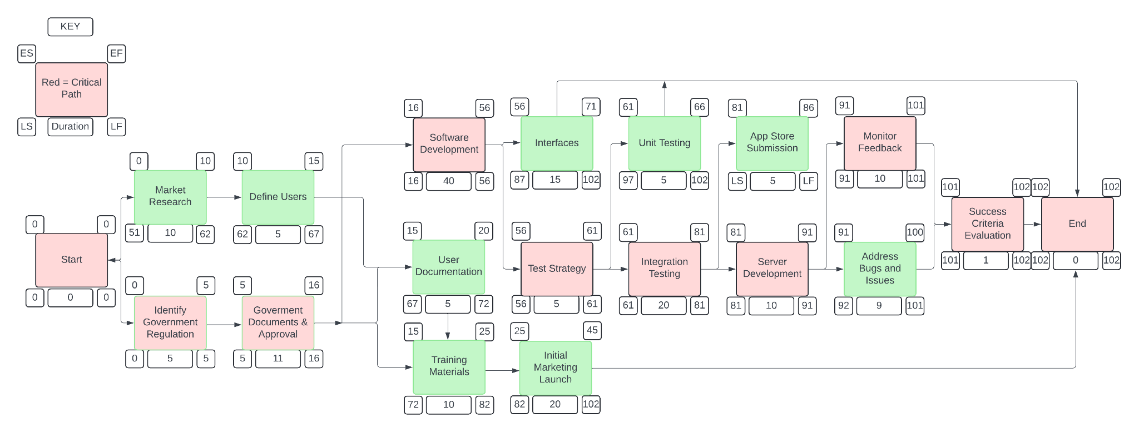

**Figure 3**

**4. Project Schedule**

* Project Nexus is expected to begin on August 1st, 2024, and is expected to end on December 20th, 2024. Our first milestone will be the start date of the actual project. Our next milestone will be government approval and our third milestone will be the creation of the application. Our next milestone will be the evaluation of our success criteria, and our last milestone is the end date, or the completion of our project.
* **Project Schedule via Gantt Chart**

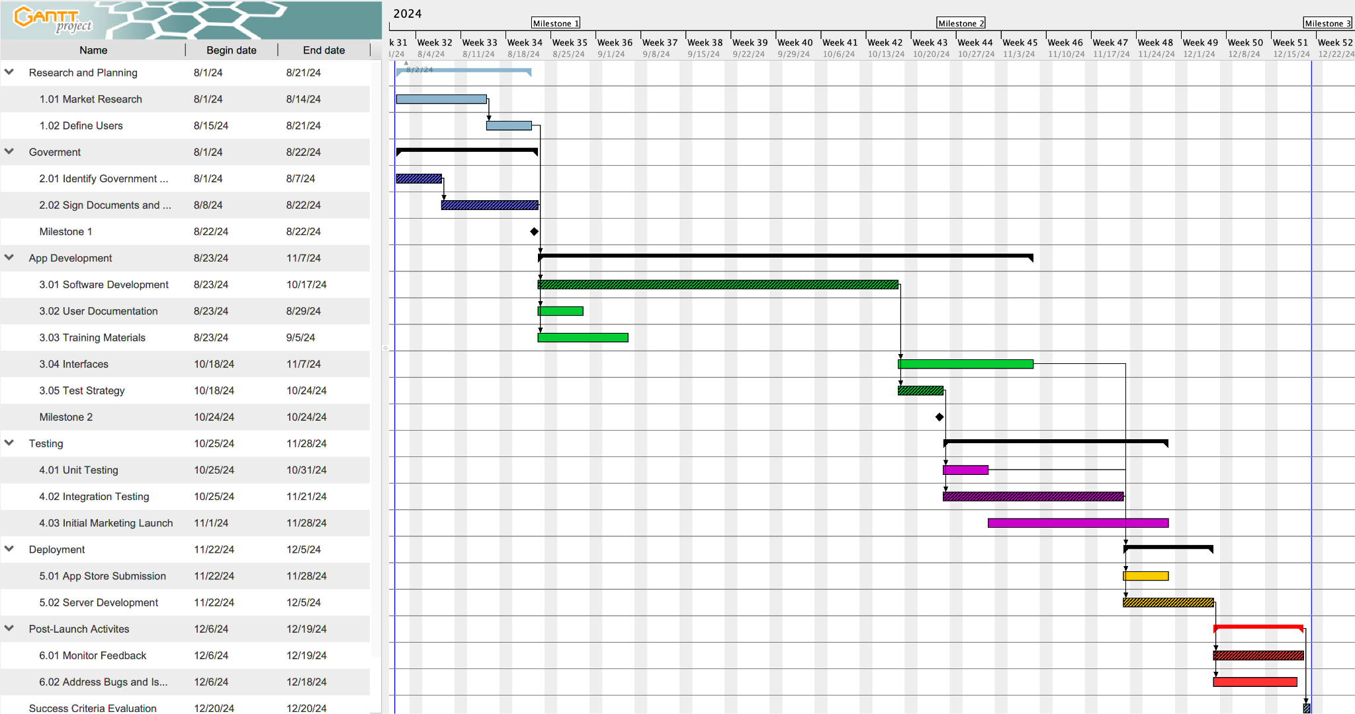

**Figure 4**

**C. Cost Management Plan**

Regarding our cost management plan, it is critical for Project Nexus to establish a project budget in order to properly allocate the necessary resources, labor, and materials towards the development and timeline of the application.

* **Cost Estimates**

a) When identifying cost estimates, our team primarily focused on the top down approach. This allowed us to identify the major financial groupings that the project would require. Following this approach, we identified the subcategories within these major groupings that require financial recognition, such as resource costs, detailed requirements, timeframe, market conditions, and various estimating techniques in order to correctly display the actions needed to meet success criteria. Figure 5 is a direct breakdown of the cost of each plan of action that is necessary throughout the timeline of this project, which totals to $170,000.

* **Cost Breakdown (Detailed breakdown in Appendices)**

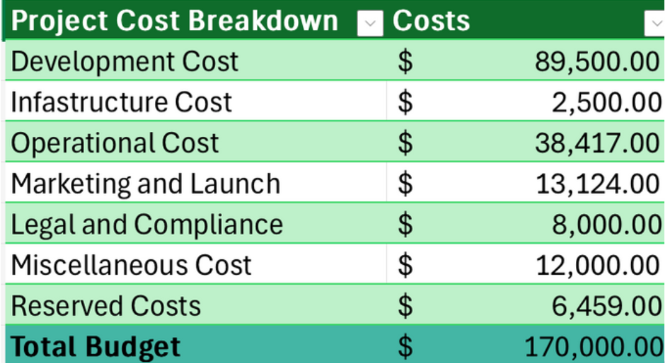

**Figure 5**

**2. Resource Management Plan**

* After establishing the project's cost estimates, our team decided to identify the various resources needed to complete the tasks throughout our timeline. To assign roles internally, each team member was assigned to a different department with varying responsibilities. Our team decided to outsource application developers and user interface designers to provide a more efficient result. Figure 6 displays these resources and the overall workload. One can see that Karishma Tirlokie and Patrick Brown; two of our internally sourced positions, are working part time which is highlighted in green. Both individuals are working simultaneously to complete tasks. In other words, it is indicated that these positions are devoting 50% to one task while the other 50% is being devoted to the other.
* **Resource Chart**

**Figure 6**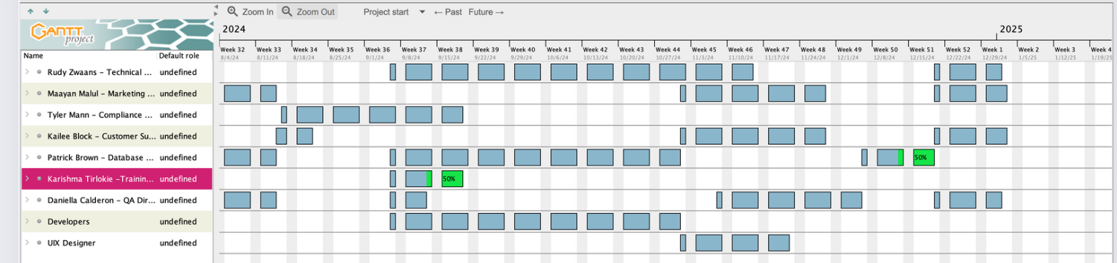

**3. Time-Phased Budget**

* A time-phased budget is an approach to allocating costs over a specific time period. This time-phased budget breaks down our overall budget based on the project schedule. This is crucial to understanding the financial needs of the project because we have decided to break down our budget on a month-to-month basis. This time-phased budget plays a role in performance management by ensuring we have enough resources available at specific times throughout the project. This empowers us to reallocate resources at low points in our time-phased budget to ensure optimal use of our resources and time.
* **Time-Phased Budget Table**

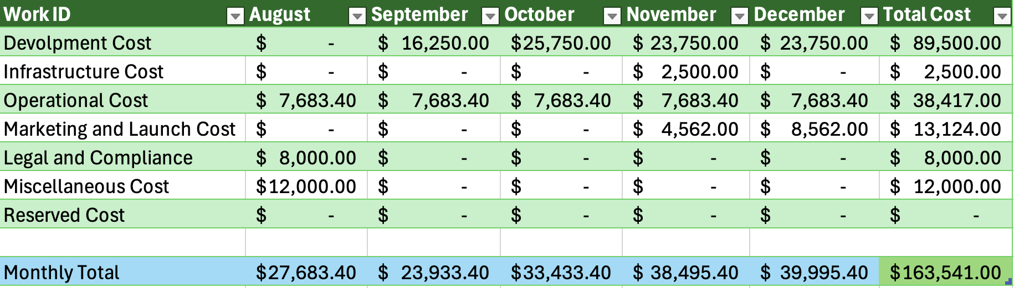

**Figure 7**

* Our Cumulative budget line chart shows how much of the project's financial requirements are needed on a monthly basis. In August and September, the project requires less financial needs because this is the time where we are researching the market, defining users, and gaining government approval. However, the next three months show a drastic increase in our budget. This is because the bulk of the application development is taking place during this time as well as our marketing plan. Both of these activities require many resources, increase in time dedicated to tasks, and attention to the development of the application. Overall, this increase shown in Figure 8 (in regards to the last three months) comes as no surprise as the outsourced roles are primarily working during these times.
* **Cumulative Budget Line Chart**

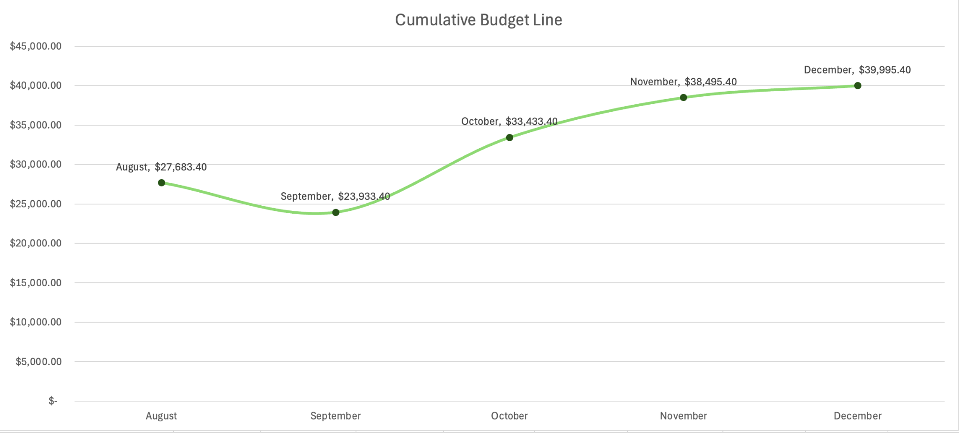

**Figure 8**

**D. Stakeholder Analysis**

* The purpose of identifying project stakeholders is to serve key roles and responsibilities in managing Project Nexus. All stakeholders are affected by the project outcomes and influence the decision-making process. Overall our stakeholders contribute to successfully developing and executing the tasks and activities within the project.

| **Stakeholder Register** | **Power** | **Interest** | **Requirements** |
| --- | --- | --- | --- |
| **IT** | Low | High | Update Technology and Design App. |
| **Government** | High | Low | Implementing approval and legal documentation |
| **Functional Managers** | Medium | High | Provide a timeline for the project and allocate resources. |
| **Project Sponsor** | High | High | Budget analysis and primary communicator to customer base. |

**Figure 9**

**E. Communication Plan**

* The purpose of identifying and documenting the project's communication needs is to ensure a clear flow of information, facilitating coordination, and collaboration among team members and stakeholders. A communication plan helps manage expectations by keeping stakeholders informed about progress, issues, and changes, thereby maintaining support and satisfaction. This approach to communication enhances transparency and contributes to the project's overall success.
* **Communication Plan Chart:**

| **Stakeholders: Information Type** | **Timing and Frequency** | **Sender** | **Receiver** | **Method of Communication** |
| --- | --- | --- | --- | --- |
| **IT:**  **Speed, privacy, and consumption data** | Inform other stakeholders once per month on the development of the app | IT Technicians and Head of IT | Functional Managers, and Project Sponsors | Email of report and designed monthly team meetings |
| **Government:**  **Approval Plans for Regulatory Compliance** | One time approval within 3 weeks of project start | Compliance Director | Department of Business and Professional Regulation, Division of Hotels and Restaurants, Office of Program Quality | Email of report |
| **Functional Manager(s): Workload, resource allocation, performance metrics** | Inform other stakeholders on the project development and provide analysis/feedback once per week | Assigned Manager and assistants | IT Department, Project Sponsors, and client/customer | Team meetings and company reports |
| **Project Sponsor(s):**  **Financial data, risk assessments, and compliance** | Bi-weekly Interactions | Head Project Sponsor and assistants | Customer(s) who are primary decision maker | Emails and face to face interaction |

**Figure 10**

**F. Key Assumptions**

* Project Nexus will get Government Approval and legal documentation that is needed to proceed through the project.
* The application will be approved when submitting it to the App store.
* We assume that as the application is being developed the landscape of technology will not change.
* We assume the server host will have the capacity throughput for our application and have no downtime due to the fact that we are renting out servers for our app not purchasing them.

**G. Project Nexus Prolifics**

* **Request for Government, Proposal**

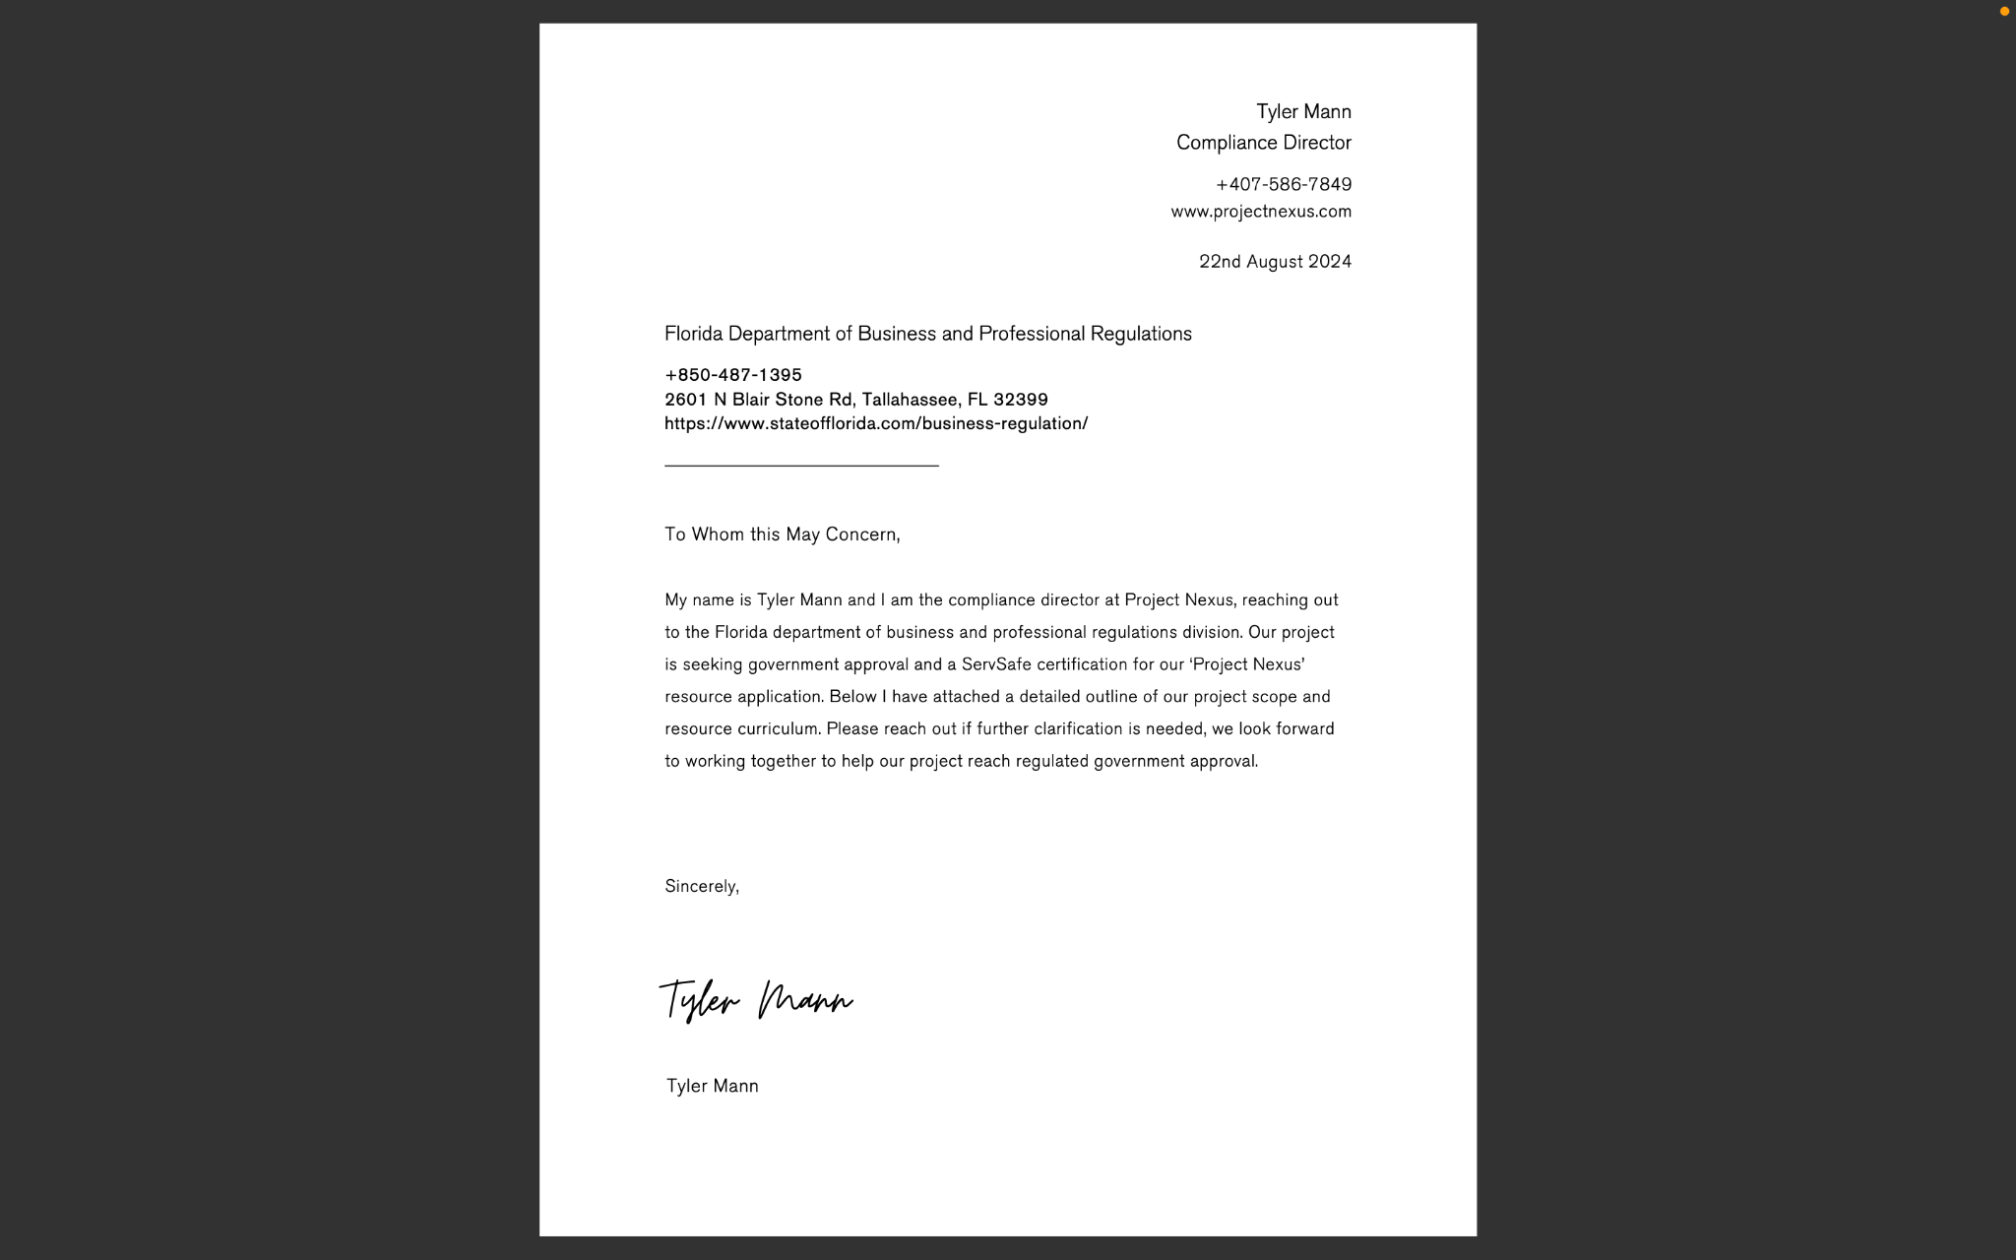

**Figure 11**

* **Closure Checklist**

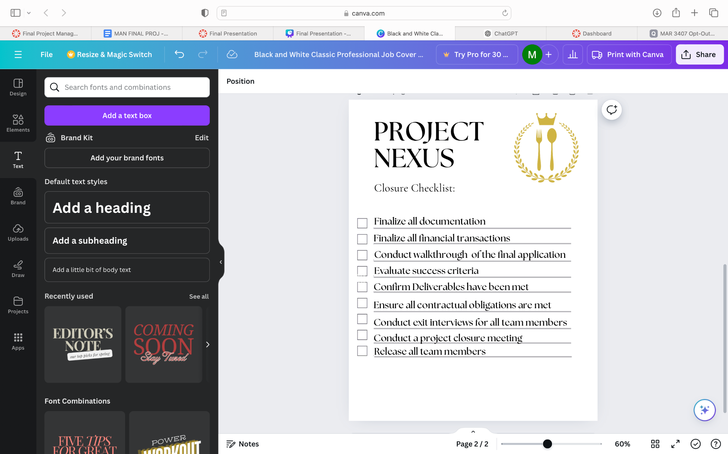

**Figure 12**

**H. Appendices**

* **Project Nexus Cost Breakdown**

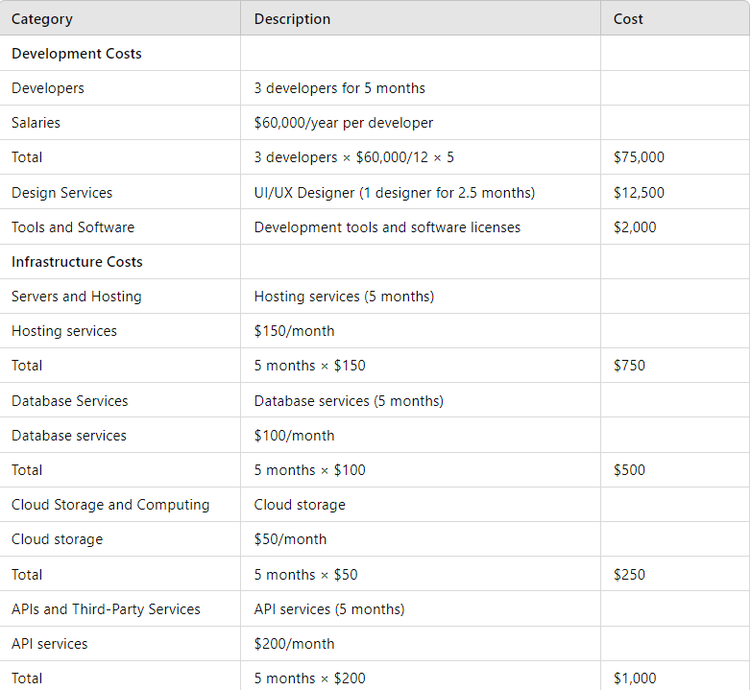

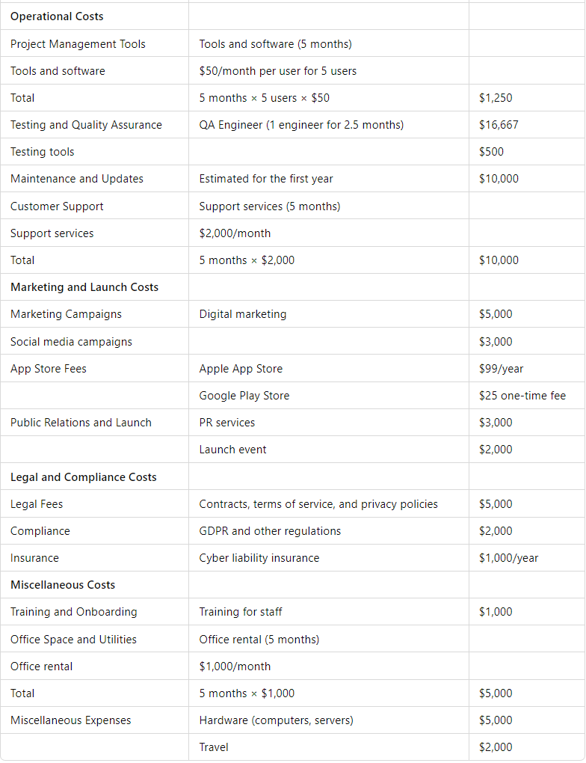

**Figure 13**

* Success Criteria: Our Goal based on these financials is to reach 1022 subscribers in one month after launch.
* To break even and be profitable by the end of seven months after launch, we must hit this metric using the math as followed:

| **Cost** | $164,541 |
| --- | --- |
| **Profit** | $50,000 |
| **Total** | $214,541 |

**Figure 14**

* A monthly goal of $30,649 is found by taking $214,541 divided by 7 months
* 1,022 subscribers are needed to hit our goals, taking $30,649 divided by 30.

**References**

HACCP Consulting Group. (2023). Our services. HACCP Consulting Group, LLC. https://haccpcg.com/services/

Amazon. (2023). Mobile Application Development - Amazon AWS. What is Mobile Application Development? https://aws.amazon.com/mobile/mobile-application-development/

GanttProject. (2024). Free Project Management Tool for Windows, macos and linux. GanttProject. https://www.ganttproject.biz/

Marketing, C. P. (2024, March 22). App Development Costs (a breakdown). The Couchbase Blog. https://www.couchbase.com/blog/app-development-costs/

LucidChart. (2023). Diagram software. Lucidchart. https://www.lucidchart.com/pages/landing/diagram-software?utm_source=google&utm_medium=cpc&utm_campaign=_chart_en_us_mixed_pmax_strategic_&km_CPC_CampaignId=18274025163&km_CPC_AdGroupID=&km_CPC_Keyword=&km_CPC_MatchType=&km_CPC_ExtensionID=&km_CPC_Network=x&km_CPC_AdPosition=&km_CPC_Creative=&km_CPC_TargetID=&km_CPC_Country=9011784&km_CPC_Device=c&km_CPC_placement=&km_CPC_target=&gad_source=1&gclid=Cj0KCQjwpZWzBhC0ARIsACvjWROOUgMxnpkbC8o5AGsoPdATA614fIX2BZt_KTJ1hrTGuw2XYBN98yYaAlFZEALw_wcB

The Upwork Team. (2023). How to develop an app in 9 easy steps (2023 guide) | upwork. Upwork. <https://www.upwork.com/resources/how-to-develop-an-app>

How to fix high restaurant employee turnover. Notch. (2024, JANUARY 5). <https://notch.financial/blog/restaurant-turnover-rate/#:~:TEXT=AMONG%20THE%20MANY%20METRICS%20THAT,BEEN%20RISING%20FOLLOWING%20THE%20PANDEMIC.>

Staff, F. L. F. (2023, May 16). App Legal Requirements. <https://www.forwardlawfirm.com/2023/05/services/startup/legal-requirements-for-your-app-what-you-need-to-know/>

**Contribution Chart**

| **Team Name:** | Project Nexus, Group 1 |
| --- | --- |
| **Section Number:** | 001 |
| **Team Member Names** | **Team Member Contribution** |
| Maayan Malul | Assisted with the scope, cost, and communication management plans. |
| Kailee Block | Assisted with the cover page/format, the schedule management plan, and the communication management plan. |
| Patrick Brown | Assisted with the cost estimates, resource management plan, and time phased budget. |
| Tyler Mann | Assisted with the scope management plan, schedule management plan, and cost estimate plan. |
| Rudolph Zwaans | Financial plan, Budget Chart, Budget Allocation, Time-Phased Budget, Cumulative Budget Line Graph. |
| Karishma Tirlokie | Assisted with the work breakdown structure, schedule management plan, and the communication management plan. |
| Daniella Calderon | Contributed to the Stakeholder Analysis and Key Assumptions |